2nd SHEFFIELD CHILDREN’S HOSPITAL PAEDIATRIC ORTHOPAEDICS AND TRAUMA SKILLS (SPOTS) COURSE
16th – 18th May 2018
VENUE: SHEFFIELD CHILDREN’S HOSPITAL
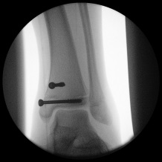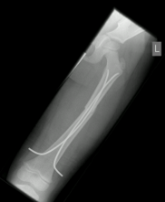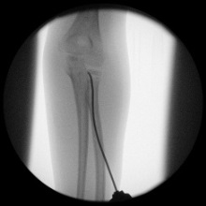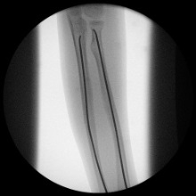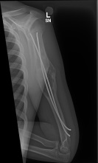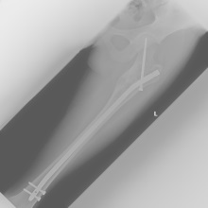
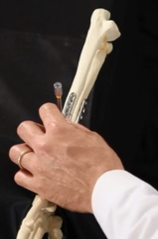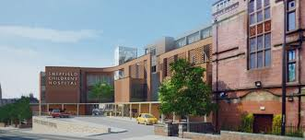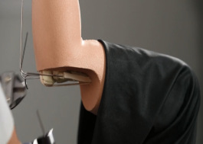
A 3 day course designed to cover paediatric practical skills for revalidating Consultants and Senior Trainees.
www.spotscourse.com
•International Faculty, interactive instructional lectures
•Breakout sessions with hands-on technique training, sawbone workshops and operative simulation
•16 CPD Points
•STOP PRESS: NEW CADAVERIC LAB SESSION ON PAEDIATRIC UPPER LIMB INCLUDED
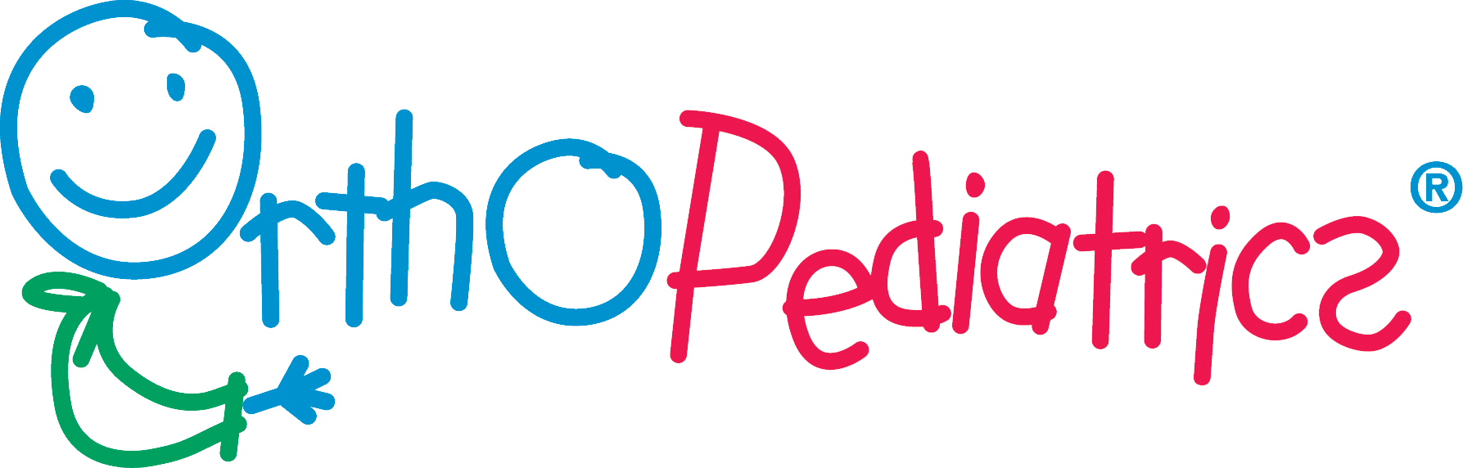

PAEDIATRIC ORTHOPAEDIC AND TRAUMA SKILLS COURSE- TIMETABLE
Wednesday 16th May:
08:30-09:00 Registration
09:00-09:15 Introduction and Housekeeping
09:15-9:45 Forearm, Wrist and Monteggia Fractures
10:15-10.45 Principles of Elastic Nailing
10:45-11:15 Supracondylar/ Lateral Condyle Fractures
11:15-11:45 Coffee
11:45- 12:20 Fractures of the Tibia and Around the Ankle
12:20-13:00 Physeal Injuries Principles/Complications
13:00-14:00 Lunch
14:00-15:00 Breakout practical sessions- All Faculty
15:00-16:00 Breakout practical sessions- All Faculty
16:15-16:30 Coffee
16:30-17:30 Breakout practical sessions- All Faculty
17:30-18:00 Interactive Case Discussions- Upper limb Trauma All Faculty

Thursday 17th May:
08:30-09:15 Advanced Elastic Nailing Techniques
09:15-10:00 Fractures of the Femur
10:00-10:30 Coffee
10:30-11:15 Normal Variants in Paediatric Orthopaedics
11:15-12:15 Paediatric Infection Update
12:15-12:45 Knee Injuries and Fractures around the Knee
12:45-13:15 Perthes Disease
13:15-14:00 Lunch
14:00- 15:00 Breakout sessions- All Faculty
15:00-16:00 Breakout Sessions- All Faculty
16:00- 16:15 Coffee
16:15-17:15 Breakout sessions- All Faculty
17:15-17:45 Interactive Case Discussions-Lower Limb Trauma

Friday 18th May:
08:30-0900 CTEV
09:00-09:30 Paediatric Foot and Ankle Pathology
09:30-10:15 Developmental Dysplasia of the Hip
10:15-10:45 Slipped Capital Femoral Epiphysis
10:45-11:15 Coffee
11:15-12:00 Breakout Session- All Faculty
12:00-12:45 Breakout Session- All Faculty
12:45-13:30 Lunch
13:30 -14:30 Cadaveric Lab Sessions (University of Sheffield)
Course close and certificates

Breakout Sessions
Instructional Interactive Practical Simulation Session 1:
Supracondylar Humerus wiring sawbones workshop and Forearm plating for fractures. Wiring techniques, Instructional technique demonstration, tricks and tips, alternative treatment. Soft tissue sawbones model,
Instructional Interactive Practical Simulation Session 2:
Ankle and proximal tibial physeal injuries sawbones workshop. Triplane injuries, Tillaux fractures, other physeal injuries, tricks and tips
Instructional Interactive Practical Simulation Session 3:
Distal femoral physeal fractures sawbones workshop. Wiring and screw fixation techniques. Advanced techniques. Case discussions, tricks and tips
Instructional Interactive Practical Simulation Session 4:
Femoral Elastic Stable Intramedullary Nailing clear sawbones workshop. Tricks and tips, alternative and advanced wiring techniques, case discussion
Instructional Interactive Practical Simulation Session 5:
Forearm Elastic Stable Intramedullary Nailing clear sawbones workshop. Entry point options, pitfalls, tricks and tips. Other elastic nailing techniques for the upper limb
Instructional Interactive Practical Simulation Session 6:
Lateral entry nailing for adolescent femoral fractures (Pedi nail) clear sawbones workshop. Tricks and tips, case discussion, indications
Instructional Interactive Practical Simulation Session 7:
Hip Spica application technique with toddler model, table and positioning, pitfalls, tricks and tips. Pavlik Harness application for infant femoral fractures, case discussions.
Instructional Interactive Practical Simulation Session 8:
Ponseti casting for CTEV with deformity models. Boots and Bar application. Tricks and tips, case discussion of relapse and recalcitrant deformities.
Instructional Interactive Practical Simulation Session 9:
SCFE percutaneous pinning simulation model. Radiologically assisted custom made model of a moderate slip (note lead protection will be required for this session). Tricks and tips, pitfalls, options for severe slips.

Cadaveric Laboratory Session: Shoulder to elbow cadaveric specimen. Demonstration of surgical techniques (ESIN forearm, radial neck fracture, supracondylar fractures, nerve dissection in relation to paediatric trauma, plus any other approaches required by delegates).
Local Faculty (Sheffield Children’s Hospital):
Mr John Cashman-Consultant Paediatric Orthopaedic Surgeon
Mr James Fernandes-Consultant Paediatric Orthopaedic Surgeon
Mr Geraint Davies-Consultant Paediatric Orthopaedic Surgeon
Mr Mark Flowers-Consultant Paediatric Orthopaedic Surgeon
Mr Nick Nicolaou-Consultant Paediatric Orthopaedic Surgeon
Mr Stephen Giles-Consultant Paediatric Orthopaedic Surgeon
Mr Sanjeev Madan-Consultant Paediatric Orthopaedic Surgeon
Mr Mike Bell (retired) -Consultant Paediatric Orthopaedic Surgeon
Mr Owain Evans- Consultant Paediatric Orthopaedic Surgeon
UK National Faculty
Prof Rohan Rajan-Consultant Paediatric Orthopaedic Surgeon-Derby
Mr Naidu Subramanyam- Consultant Paediatric Orthopaedic Surgeon- Brighton
Mr Om Lahoti-Consultant Paediatric Orthopaedic Surgeon-King’s London
Mr David Rowland-Consultant Paediatric Orthopaedic Surgeon-Glasgow Children’s
Mr Anish Sanghrajka-Consultant Paediatric Orthopaedic Surgeon-Norfolk & Norwich
Mr Sunil Bajaj-Consultant Paediatric Orthopaedic Surgeon South London Healthcare
Mr James Metcalfe- Consultant Paediatric Orthopaedic Surgeon- Plymouth
Mr Shabih Siddiqui- Consultant Paediatric Orthopaedic Surgeon- Kettering
Mr Assad Quereshi- Consultant Paediatric Orthopaedic Surgeon- Leicester
Mr Robert Kucharski- Consultant Paediatric Orthopaedic Surgeon- Doncaster
Miss Kuldeep Stohr- Consultant Paediatric Orthopaedic Surgeon- Cambridge
International Faculty
Prof Eric Gordon- St Louis Children’s and Shriners St Louis- US
Mr Senbaga Needhirajan- Koimbatore- India
Mr Per Lanert- Linkoping-Sweden
Oher International Speakers to be confirmed
COURSE FEE: £350.00
CPD: 16 CPD Points awarded by the British Orthopaedic Association
To register please send a cheque for £350.00 with this page. Early registration and booking of leave recommended. Cancellation, full refund until 19th April 2018.
Cheques payable to the Paediatric Orthopaedic Research Fund
C/o Lynne Flanagan- Course Administrator
Department of Orthopaedics, Sheffield Children’s Hospital, Western Bank Sheffield S10 2TH.
BACS payments: NatWest Bank
Sort code: 544134
Account number: 22765832
IBAN: GB78NWBK54413422765832

Contact: lynne.flanagan@sch.mhs.uk tel 0114 2717094
Course Conveners:
Mr Steve Giles Consultant Orthopaedic Surgeon Stephen.Giles@sch.nhs.uk
Mr Nick Nicolaou Consultant Orthopaedic Surgeon Nicolas.nicolaou@sch.nhs.uk

NAME_____________________________________

GRADE____________________________________

HOSPITAL_________________________________

E-MAIL ADDRESS__________________________

Recommended Accommodation:
We have worked with “Visit Sheffield” to get preferential rates for hotel accommodation during the course. Use this link to book your preferred hotel: https://aws.passkey.com/e/49549731
